**Instructor Guide for MEASURE**

Faculty of Engineering, McMaster University

July 30, 2021

**by**

Evan Situ, Michelle Zheng, Spencer Smith, and Andrew Aran

**Modification Log**

|  |  |  |  |
| --- | --- | --- | --- |
| **Version** | **Modification Date** | **Author** | **Comments** |
| 3.01 | July 30, 2021 | Andrew Aran | * Updated text to rubric entry process * Updated instructions for accessing Annual & YoY Attribute reports |
| 3.00 | January 9, 2020 | Andrew Aran | * Updated to reflect MEASURE 3.0 |

Click here to view previous modification log.

Table of Contents

Introduction 6

Prerequisites 7

Windows 7

System Requirements 7

About the Vena Add-In 7

Installing Vena Add-In for Windows Users 7

Enabling Trust Access to the VBA Project Object Model 8

macOS 10

System Requirements 10

About the Vena Contributor Connector 10

Installing Vena for Mac Users 10

Enabling Trust Access to the VBA Project Object Model 12

Other Operating Systems 13

Instructions to Access a Virtual Machine: 13

Questions/Comments/Technical Support: 13

Annual Timeline 14

Accessing Vena 16

Changing Vena Password 16

Instructor Input 17

Vena Checklist 17

Windows Guide 17

Accessing Rubric Input Template 17

Updating Rubric Input Template 19

Viewing Summary Chart 22

Viewing Detailed Chart 24

macOS Guide 25

Accessing Rubric Input Template 25

Updating Rubric Input Template 26

Viewing Summary Chart 29

Viewing Detailed Chart 30

Reports 30

Accessing the Reports 32

CEAB Annual Attribute Report 33

Viewing the Annual Attribute Report 33

CEAB YoY (Year over Year) Attribute Report 34

Viewing the YoY Attribute Report 34

Faculty and Curriculum Committee Recommendation Report 35

Historical Course Measurement Report 36

Historical Program Measurement Report 36

Measurement Map Report 37

Cascade 38

Generating a Mass Course Report 38

Appendix I: Report Overview 40

Appendix II: Previous Modification Log 41

# Introduction

The Instructor’s Guide describes part of MEASURE (McMaster Engineering Accreditation System for UndeRgraduatE).

MEASURE’s purpose is to:

* Facilitate the continual improvement of the curriculum of the programs offered by the Faculty of Engineering
* Assist with generating accreditation reports for the Canadian Engineering Accreditation Board (CEAB)

MEASURE is built using corporate performance management software, (Vena) that combines Excel spreadsheets, a central database, and workflow management.

This document outlines the MEASURE tasks that take place at the instructor level.

Specifically, each instructor will update the Rubric Input Template for each section of every course taught.

Additional information on MEASURE can be found in the Administrator’s Guide and in the Department Contributor’s Guide. The latest version of all these documents, along with other resources, are available at <http://measure.mcmaster.ca>

Issue Reporting: <https://www.eng.mcmaster.ca/forms/measure-issue-tracking>

Technical Support: [measure@mcmaster.ca](mailto:measure@mcmaster.ca)

# Prerequisites

## Windows

### System Requirements

|  |  |  |
| --- | --- | --- |
|  | **Recommended** | **Minimum** |
| **Operating System** | Latest version of Windows 10 (64-bit) | Windows 7 (32-bit) |
| **MS Office** | Office 2016 or newer   * Click [here](https://www.mcmaster.ca/uts/licensing/msemployees.html) for instructions to download Office (via UTS) | Office 2010 |
| **.NET** | Latest version of .NET | 4.5 |
| **Browser** | Latest version of:   * Internet Explorer * Microsoft Edge * Mozilla Firefox * Google Chrome | * Internet Explorer 10+ * Microsoft Edge * Mozilla Firefox 12.0+ * Google Chrome |
| **RAM** | 16 GB | 4 GB |
| **CPU** | 2+ Cores | -- |
| **Reference:** | <https://support.venasolutions.com/hc/en-us/articles/115000622006-Vena-Add-In-System-Requirements> | |

### About the Vena Add-In

Vena uses both Microsoft Excel and the Vena website (<https://vena.io>) to give users access to the rubric input template and various accreditation reports. Before users can update their course data in Excel, they will need to install the Vena Add-In for Microsoft Excel. This Add-In provides functionality to Excel that allows users to view, edit, and save their rubric data to the Vena cloud.

### Installing Vena Add-In for Windows Users

1. Visit the add-in website <http://addin.vena.io/release/vena.application>
2. Save the **vena.application** file
3. Double-click the **vena.application** file



1. Run the installer. The following dialog box will appear:

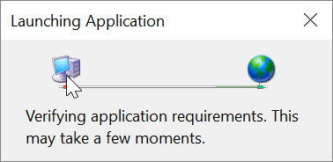

1. When the application has loaded, press **Install**

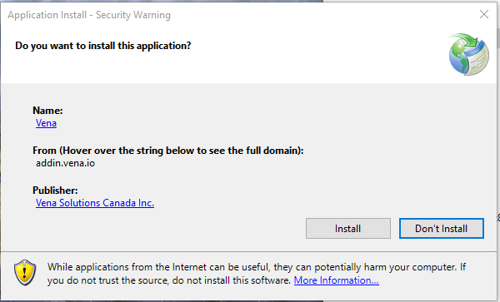

1. When the installation has completed, the following dialog box will appear. **Close** this dialog box to complete the installation.

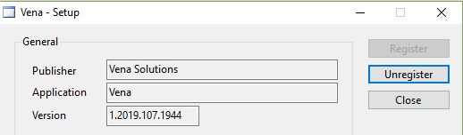

1. To ensure Vena has successfully installed, open Microsoft Excel, and confirm the Vena tab has been added.

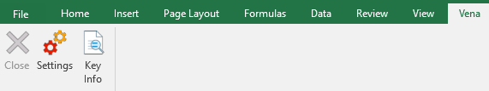

### Enabling Trust Access to the VBA Project Object Model

After installing the Excel Vena Add-in, access to the VBA project object model will need to be trusted for Vena to run properly.

1. Open **Excel**
2. Select a **Blank Workbook**
3. Select **File**

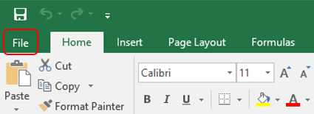

1. On the bottom of the left menu, select **Options**

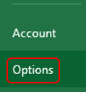

1. Select **Trust Center**
   1. Select **Trust Center Settings**

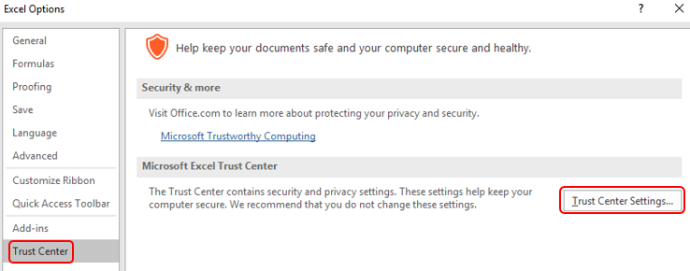

1. Select **Marco Settings**
2. Ensure that **Disable all macros with notification** is selected
3. Check the box next to **Trust access to the VBA project object model**

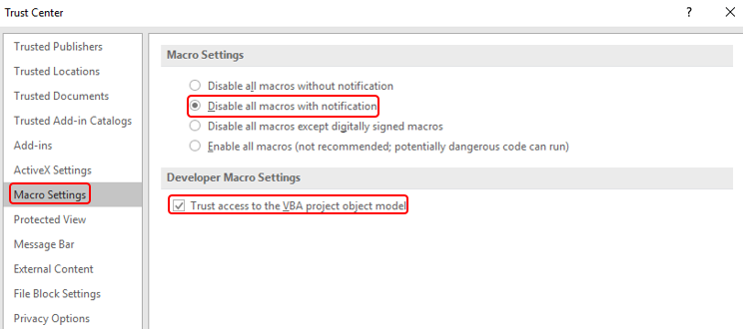

1. Close all instances of Excel for the settings to take effect.

## macOS

### System Requirements

|  |  |  |
| --- | --- | --- |
|  | **Recommended** | **Minimum** |
| **Operating System** | Mac OS X version 10.10 or later | -- |
| **MS Office** | Office 2016 for Mac or newer   * Click [here](https://www.mcmaster.ca/uts/licensing/msemployees.html) for instructions to download Office (via UTS) | -- |
| **Browser** | Latest version of:   * Internet Explorer * Microsoft Edge * Mozilla Firefox * Google Chrome | * Internet Explorer 10+ * Microsoft Edge * Mozilla Firefox 12.0+ * Google Chrome |
| **RAM** | 4 GB | -- |
| **CPU** | A Mac computer with an Intel processor | -- |
| **Reference:** | <https://products.office.com/en-us/office-system-requirements> | |

### About the Vena Contributor Connector

The Contributor Connector is a special version of the Vena Add-In that is designed for Office for Mac and Office Online.

Similar to the Windows Add-In, the Contributor Connector enables users to perform various Vena functions in Excel, such as saving data inputs to the Vena database, choosing among data sets, drilling on intersection data, and working with Line Item Details.

### Installing Vena for Mac Users

1. Open **Microsoft Excel for Mac**
2. Select the **Insert** tab

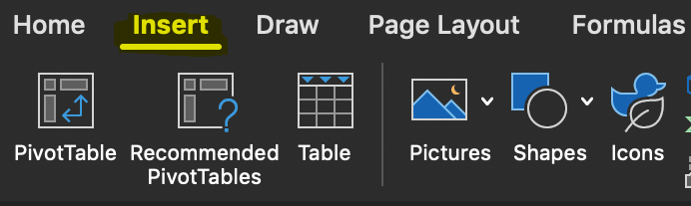

1. Select **Get Add-ins**

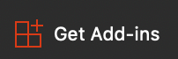

1. Search for “Vena Connecter”

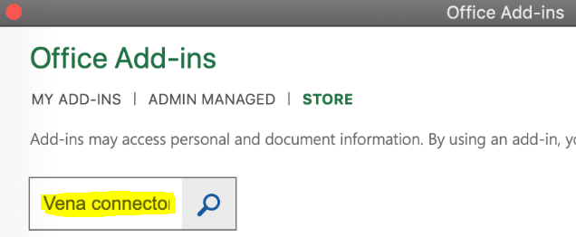

1. Press **Add**

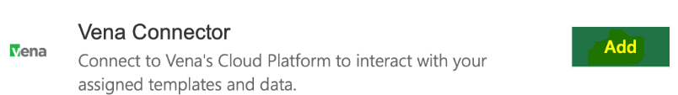

1. After successfully adding the Vena Connector, the Vena add-in icon will be displayed under the Insert tab.

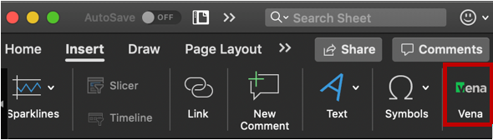

If Microsoft Office is preventing the installation of the add-in (i.e. Office has been configured to not allow individual add-ins), it is because the user is signed in as a domain user (ads.mcmaster.ca).

Signing in as a domain user will prevent users from adding certain Excel Add-ins because UTS controls what add-ins are allowed. Users will need to sign out to install the Vena add-in.

Steps to signing out:

1. Open **Excel for Mac**
2. Click on your initials then press sign out

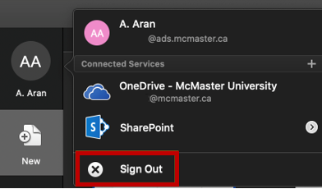

1. Confirm **sign out**

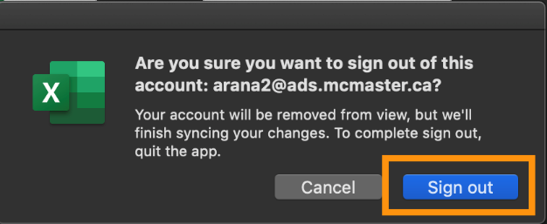

### Enabling Trust Access to the VBA Project Object Model

After successfully installing the Contributor Connector, access to the VBA project object model will need to be trusted for Vena to run properly.

1. Open **Excel**
2. Select a **Blank Workbook**
3. Select **Excel** 🡪 **Preferences**

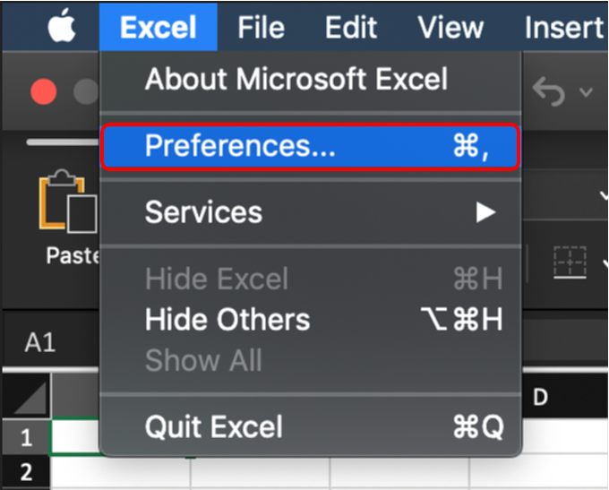

1. Under Sharing and Privacy, select **Security**

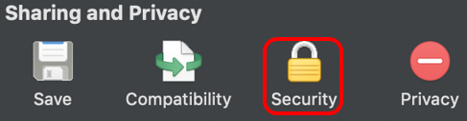

1. Ensure that **Disable all macros with notification** is selected
2. Check the box next to **Trust access to the VBA project object model**

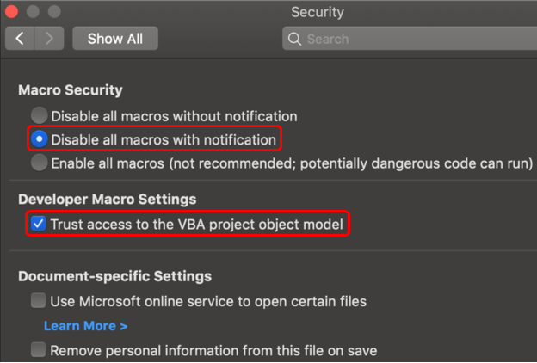

1. Close all instances of Excel for the settings to take effect.

## Other Operating Systems

Vena is currently compatible for Windows and macOS users with Microsoft Office. Users who do not have a compatible operating system and/or Microsoft Office will need to access Vena using a virtual machine.

### Instructions to Access a Virtual Machine:

<https://www.eng.mcmaster.ca/sites/default/files/vminstruct.pdf>

### Questions/Comments/Technical Support:

[measure@mcmaster.ca](mailto:measure@mcmaster.ca)

# Annual Timeline

The table below summarizes the typical tasks performed during the course of an academic year.

Instructor responsibilities are highlighted in **green**.

|  |  |  |  |  |
| --- | --- | --- | --- | --- |
| **Date** | **Task Description** | **Section** | **Template** | **Task Owner** |
| January | * Instructor enters rubric and continuous improvement plan for Term 1 | Windows  macOS | Rubric Input Template | Instructor |
| January | * Instructor reviews the continuous improvement plan from the previous year for Term 1 | Click here | Rubric Input Template and Curriculum Committee Recommendations Report (Prev. Year) | Instructor |
| January | * Review current rubric entry status * Contact users who have yet to complete their Vena rubric entry | Department Guide | See Department Guide | Department |
| April | * Update global variable and point to Term 2 (after Term 1 data entry is complete) | Admin Guide | See Administrator’s Guide | Associate Dean’s Office |
| May | * Instructor enters rubric and continuous improvement plan for Term 2 | Windows  macOS | Rubric Input Template | Instructor |
| May | * Instructor reviews continuous improvement plan from the previous year for Term 2 | Click here | Rubric Input Template and Curriculum Committee Recommendations Report (Prev. Year) | Instructor |
| May | * Review current rubric entry status * Contact instructors who have yet to complete their Vena rubric entry | Department Guide | See Department Guide | Department |
| May | * Curriculum committees review (this year) course reports and continuous improvement plan reports | Department Guide | See Department Guide | Department |
| August | * Archive previous year | Admin Guide | See Administrator’s Guide | Associate Dean’s Office |
| * Start New Academic Year |
| * Update global variable and point to Term 1 (after Term 2 data entry is complete) |
| August | * Update Measurement Mapping | Department Guide | See Department Guide | Department |
| August | * Update Curriculum Mapping   + Consult with Instructors | Department Guide | See Department Guide | Department |
| August | * Update Curriculum Recommendations | Department Guide | See Department Guide | Department |
| August | * Review Programs in Vena * Notify Associate Dean’s Office if changes are needed | Department Guide | See Department Guide | Department |
| August | * Add/Update/Un-map courses in the Vena Database * **Do not delete Courses** | Department Guide | See Department Guide | Department |
| September | * Faculty reviews departmental continuous improvement plan report from previous year * Prepare/review Graduate Attribute Report | Admin Guide | See Administrator’s Guide | Associate Dean’s Office |
| December | * Execute Backup and Restore Process | Admin Guide | See Administrator’s Guide | Associate Dean’s Office |

# Accessing Vena

1. Open a web browser
2. Visit <https://vena.io>
3. In the email textbox, enter your McMaster email address (i.e. [macid@mcmaster.ca](mailto:macid@mcmaster.ca))
4. Your password has been previously communicated. If you do not remember, or do not have an account, please contact Measure Support ([measure@mcmcaster.ca](mailto:measure@mcmcaster.ca))

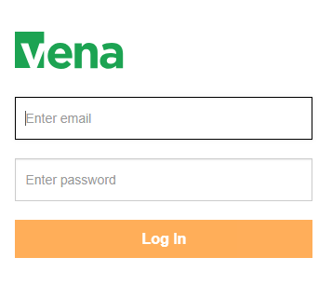

# Changing Vena Password

Your password can be changed by clicking the user’s name in the upper right corner of the screen and then selecting “Change Password”.

You will be prompted to enter the current and new password.

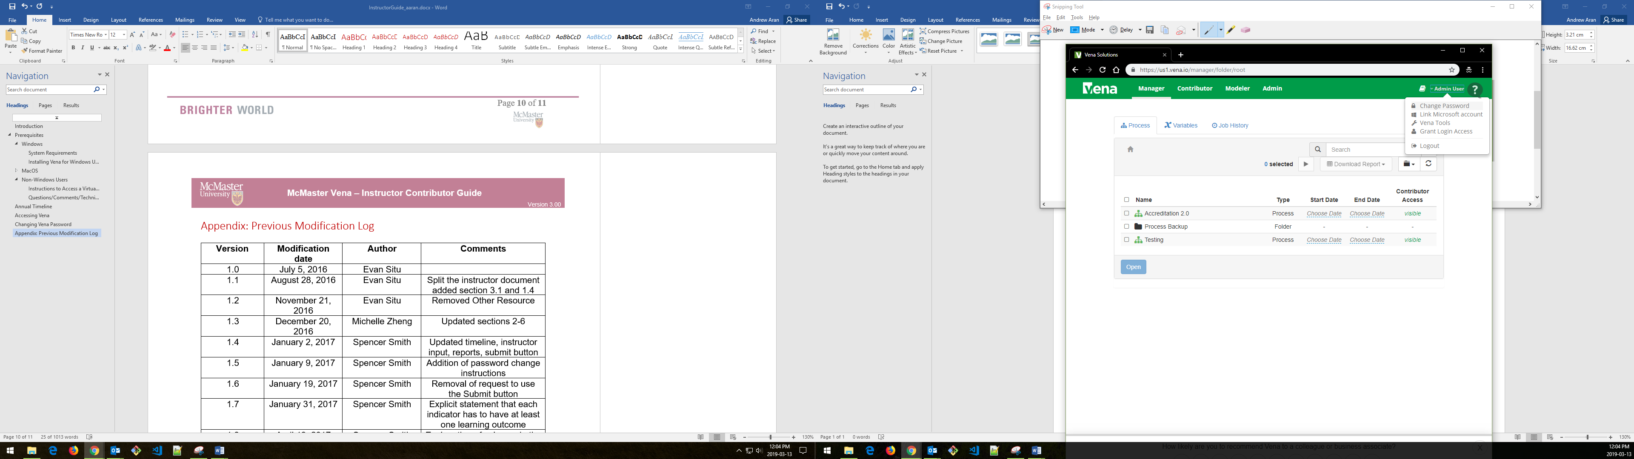

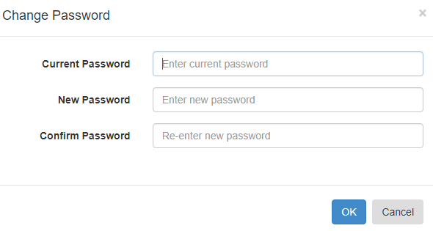

# Instructor Input

For each course being measured, the continuous improvement plan and rubric data will need to be entered and saved. They will need to be entered in a single spreadsheet called the Rubric Input Template.

When the data entry for the Rubric Input Template is complete, you are done. Although the Vena interface shows a Submit button, the button is disabled.

**\*\*\*You do not need to worry about using the Submit button\*\*\***

## Vena Checklist

Prior to entering/reviewing rubric data with Vena, please ensure the following tasks are complete:

|  |  |  |
| --- | --- | --- |
| **Task** | **Windows** | **macOS** |
| The device meets the system requirements | Click here | |
| Microsoft Excel 2010 or later is installed | Click [here](https://www.mcmaster.ca/uts/licensing/msemployees.html) | |
| Vena Add-In is installed | Click here | Click here |
| Enabling Trust Access to Vena | Click here | Click here |

## Windows Guide

This section of the guide is intended for Windows (7/8/10) operating system users.

### Accessing Rubric Input Template

1. Under Contributor view, select Task **Rubric Input & Course Report (by Instructor) - New**

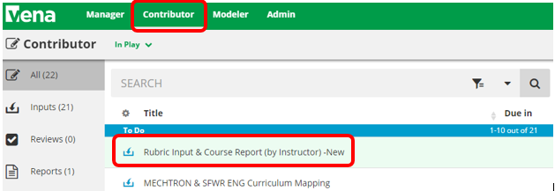

1. Select **Check Out** beside the **Rubric Input Template – Windows.xlsm**



1. A pop-up will appear to save the template. Click **save** and remember the saved location of the template.

|  |  |
| --- | --- |
| Google Chrome | Mozilla Firefox |
|  |  |

Microsoft Edge:



1. Open the Excel File
   1. If prompted, press Enable Editing in the Excel spreadsheet



* 1. If prompted, press Enable Content to allow Macros



1. Selecting the Course, Year, and Section
   1. **Program:** Select the course for data entry. Pressing the dropdown will let users see the list of available courses. However, typing the course name in the textbox will help find it quicker.
   2. **Year:** Press the dropdown button to select the corresponding year and term.
   3. **Section:** The default section is Section 1 (unless otherwise stated).

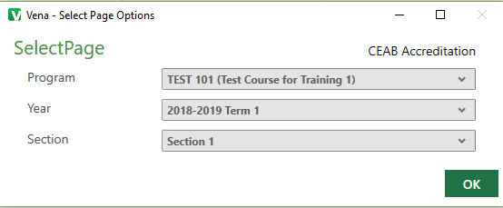

### Updating Rubric Input Template

If an instructor has entered rubric information from the previous year, the same rubric information will be carried over as a starting point for the current year.

If this is the first time a course is being measured, the user may need to insert new learning outcomes (rows) to enter the rubric data.

**Tip:** Users can enter/update data where cells are highlighted in yellow.

1. **Instructor Name**
   1. Enter the instructor’s name for the course
2. **Rubric Entry Status**
   1. Select a status from the dropdown menu
      1. Not Started – User has not entered rubric data
      2. WIP – User has entered rubric data, but not complete
      3. Fully Complete – User has completed entering rubric data

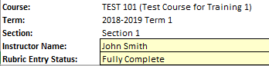

1. **Summary of Actions to be Taken for Continuous Improvement for Next Academic Year**
   1. Instructors can enter their continuous improvement plan(s) under the section “Summary of Actions to be Taken for Continuous Improvement for Next Academic Year”

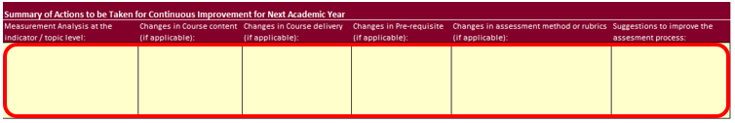

* 1. To attach a file:
     1. Select a cell
     2. Click **Comments**
     3. In the **Comments** section, click **Details** Tab
     4. Click the **Add** **Comment** button
     5. Click the **paper clip** and attach your file
     6. Click **Upload** when asked to upload the file as a comment
     7. Include text in the selected cell such as ‘**See attached file**’ to notify users the template contains attachments

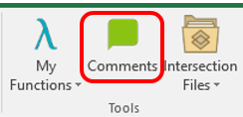

1. **Indicators/Learning Outcomes**

**Indicators** - descriptors of what students must achieve to be considered competent in the corresponding attribute

**Learning Outcomes** – descriptors of what the instructor expects the student to learn to be considered competent in the corresponding indicator

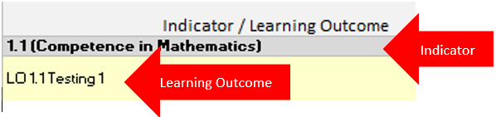

*** Every indicator must have at least (1) learning outcome (row) inserted ***

* 1. **Adding Topics (rows)**
     1. Select an **Indicator** (grey cell)
     2. Click **Insert** under the Vena Tab
        1. A new row will be inserted below the selected indicator
     3. **Enter** the learning outcome in the newly inserted row
  2. **Deleting Topics (rows)**
     1. Select the **Learning Outcome** you wish to remove
     2. Click **Remove** under the Vena Tab
        1. The selected row will be removed
  3. **Missing Indicators**
     1. If an indicator is missing or is not required, please contact your department representative or [MEASURE Support](mailto:measure@mcmaster.ca) to update the Measure Indicators Template

1. **Measurement Date**
   1. Enter the current date in YYYY-MM-DD format (e.g. 2019-12-31, etc.)
2. **Expectations**

**Description**: Describes a given expectation that applies to a learning outcome

**Number**: The numbers in this column should be the number of students that apply to the given category, not the percentage of the class in that category

* 1. **Enter** a description describing each expectation
  2. **Enter** the number of students corresponding to each expectation

1. **Used (1/0)**

The “Used (1/0)” column is updated to determine if the row will be part of the calculation for the Summary and Detailed View charts.

If users wish to record the rubric data and include it as part of the calculation for the Summary and Detailed View charts, set the value to 1.

If users wish to record the rubric data, but **not** include it as part of the calculation for the Summary and Detailed View charts, set the value to 0.

If unsure, always set the value to 1.

1. **Measurement Category**

The Measurement Category has a dropdown menu with a list of possible values pertaining to the learning outcome (i.e. Assignment, Lab, Exam, etc.)

* 1. **Select** a category from the dropdown menu for each row

1. **Attaching Sample Files**

Reminder: For privacy and security reasons, remove any information that may identify a student

To attach a file:

* + 1. Select a cell
    2. Click **Comments**
    3. In the **Comments** section, click **Details** Tab
    4. Click the **Add** **Comment** button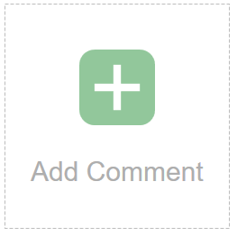
    5. Click the **paper clip** and attach your file
    6. Click **Upload** when asked to upload the file as a comment
    7. Please include text in the field such as ‘See attached file’ to notify users the template contains attachments

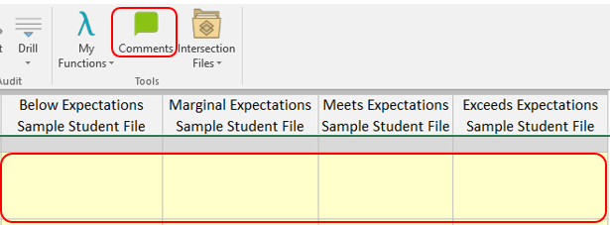

1. **Reviewing the Number Values**

After entering the student count for each expectation, ensure the sum of the line item’s equal the Indicator’s total

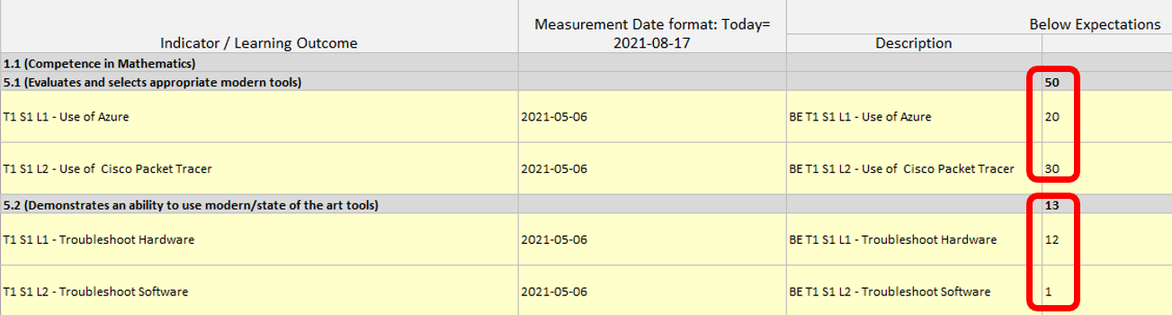

1. **Saving Data**
   1. Select the Vena Tab
   2. Click **Save Data**

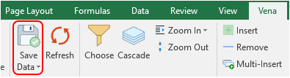

1. **Closing and Checking in the Template**
   1. When closing the Rubric Input Template, you will be prompted to **Check-in**
   2. Select **Yes**

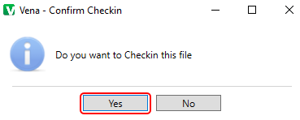

### Viewing Summary Chart

The Summary Chart is a graphical summary of every Indicator containing rubric course data. The chart may contain up to four bars where each bar represents an Expectation.

After entering/updating rubric data:

1. Press **Save Data**
2. Press the **Refresh** button under the Vena tab
3. Select the **Summary Report** worksheet

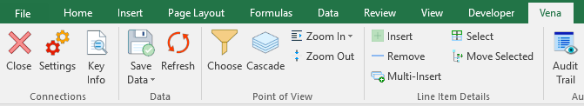

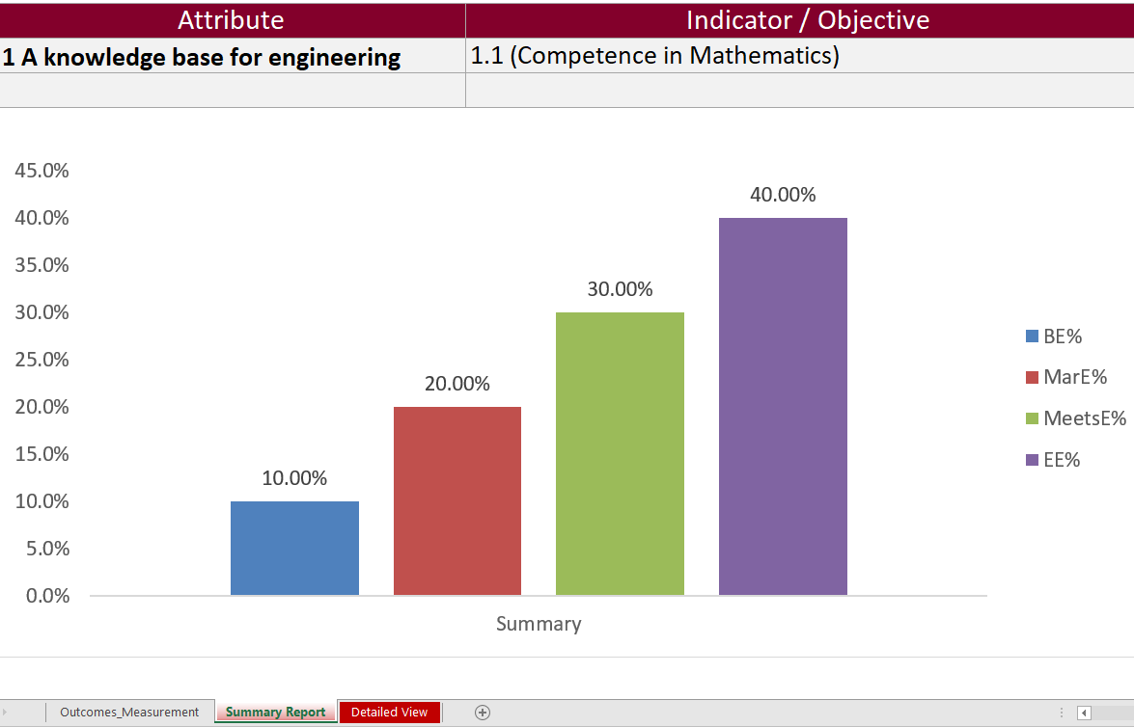

### Viewing Detailed Chart

The Detailed Chart is a graphical summary of every Learning Outcome containing rubric course data. Every learning outcome may contain up to four bars where each bar represents an Expectation.

After entering/updating rubric data,

1. Press **Save Data**
2. Press the **Refresh** button under the Vena tab
3. Select the **Detailed View** worksheet



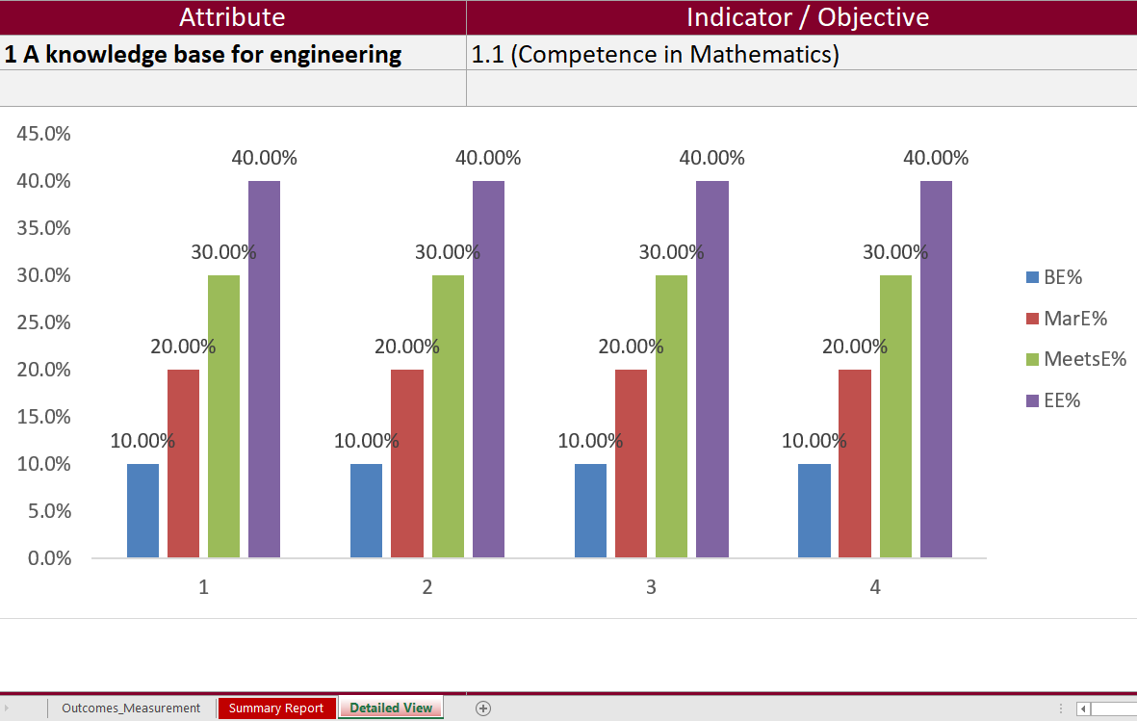

## macOS Guide

This section of the guide is intended for macOS users.

### Accessing Rubric Input Template

1. Under Contributor view, select on Task **Rubric Input & Course Report (by Instructor) - New**



1. Select **Check Out** beside the **Rubric Input Template – macOS.xlsm**



1. A new section will display to select the Course, Year, and Section
   1. **Program:** Select the course for data entry. Pressing the dropdown will let users see the list of available courses. However, typing the course name in the textbox will help find it quicker.
   2. **Year:** Press the dropdown button to select the corresponding year and term.
   3. **Section:** The default section is Section 1 (unless otherwise stated).

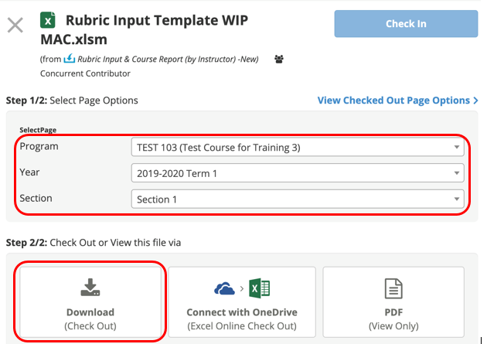

1. Press **Download (Check Out)**



1. A pop-up will appear to save the template. Click **save** and remember the saved location of the template.

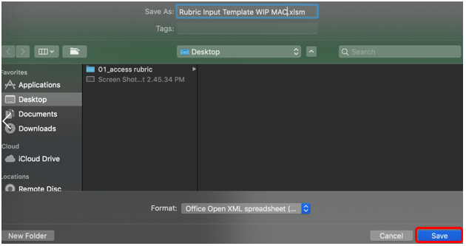

1. **Open** the Excel File
   1. If prompted, press **Enable Macros**

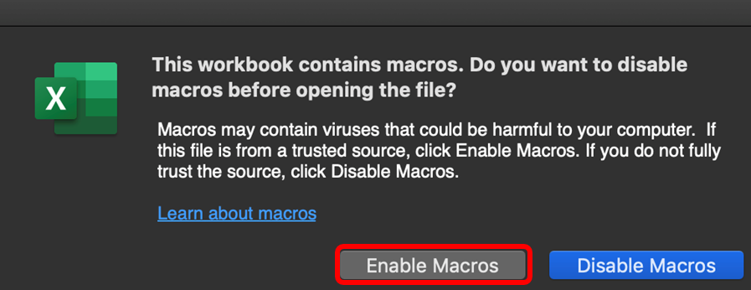

### Updating Rubric Input Template

If an instructor has rubric information from the previous year, the same rubric information will be prepopulated as a starting point for the current year.

If this is the first time a course is being measured, the user may need to insert new learning outcomes (rows) to enter the rubric data.

**Tip:** Users can enter/update data where cells are highlighted in yellow.

1. **Instructor Name**
   1. Enter the instructor’s name for the course
2. **Rubric Entry Status**
   1. Select a status from the dropdown menu
      1. Not Started – User has not entered rubric data
      2. WIP – User has entered rubric data, but not complete
      3. Fully Complete – User has completed entering rubric data

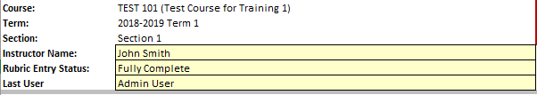

1. **Updated By:**
   1. Enter your name
2. **Summary of Actions to be Taken for Continuous Improvement for Next Academic Year**
   1. Instructors can enter their continuous improvement plan(s) under the section “Summary of Actions to be Taken for Continuous Improvement for Next Academic Year”



* 1. To attach a file:
     1. Select a cell
     2. Under Vena Comments, click **Add New**
     3. Below the comments, click **Attach**
     4. Select your file and click **Open**
     5. The new file will be displayed as an attachment in the comments section
     6. Press the back arrow button 
     7. Click **Save** to save the changes
     8. When re-opening the template, the cell containing the attachment will now be highlighted in blue for visibility

1. **Indicators/Learning Outcomes**

**Indicators** - descriptors of what students must achieve to be considered competent in the corresponding attribute

**Learning Outcomes** – descriptors of what the instructor expects the student to learn to be considered competent in the corresponding indicator



*** Every indicator must have at least (1) learning outcome (row) inserted ***

* 1. **Adding Topics (rows)**
     1. Select an **Indicator** (grey cell)
     2. Click the  button under the Line Item Details section
        1. A new row will be inserted below the selected indicator
     3. **Enter** the Learning Outcome in the newly inserted row
  2. **Deleting Topics (rows)**
     1. Select the **Learning Outcome** you wish to remove
     2. Click button under the Line Item Details section
        1. The selected Learning Outcome row will be removed
  3. **Missing Indicators**
     1. If an indicator is missing or is not required, please contact your department representative or [MEASURE Support](mailto:measure@mcmaster.ca) to update the Measure Indicators Template

1. **Measurement Date**
   1. Enter the current date in YYYY-MM-DD format (e.g. 2019-12-31, etc.)
2. **Expectations**

**Description**: Describes a given expectation that applies to a learning outcome

**Number**: The numbers in this column should be the number of students that apply to the given category, not the percentage of the class in that category

* 1. **Enter** a description and number for each expectation

1. **Used (1/0)**

The “Used (1/0)” column is updated to determine if the row will be part of the calculation for the Summary and Detailed View charts.

If users wish to record the rubric data and include it as part of the calculation for the Summary and Detailed View charts, set the value to 1.

If users wish to record the rubric data, but not include it as part of the calculation for the Summary and Detailed View charts, set the value to 0.

If unsure, always set the value to 1.

1. **Measurement Category**

The Measurement Category has a dropdown menu with a list of possible values pertaining to the learning outcome (i.e. Assignment, Lab, Exam, etc.)

1. **Select** a category from the dropdown box for each row.
2. **Attaching Sample Files**

Reminder: For privacy and security reasons, remove any information that may identify a student

To attach a file:

* + 1. Select a cell
    2. Under Vena Comments, click **Add New**
    3. Below the comments, click **Attach**
    4. Select your file and click **Open**
    5. The new file will be displayed as an attachment in the comments section
    6. Press the back arrow button 
    7. Click **Save** to save the changes
    8. When re-opening the template, the cell containing the attachment will now be highlighted in blue for visibility

1. **Reviewing the Number Values**

After entering the student count for each expectation, ensure the sum of the line item’s equal the Indicator’s total



1. **Saving Data**
   1. Click the  button
   2. If successful,  will temporarily appear over the save button
2. **Closing and Checking in the Template**

After saving the changes and closing the Excel template, you will need to go back to the web browser and check the file back in.

* 1. **Open** your web browser
  2. Visit **Vena** (<https://vena.io>)
  3. Under Contributor view, click on **Task Rubric Input & Course Report (by Instructor) - New**
  4. Press the **Check-In** button next to the template currently checked out



### Viewing Summary Chart

The Summary Chart is a graphical summary of every Indicator containing rubric data. The chart may contain up to four bars where each bar represents an Expectation.

After entering/updating rubric data:

1. Click the  button
2. On the template, button
3. Select the **Summary Report** worksheet.



**Tip**: If the charts do not reflect the data, click Vena’s Save button, close and check-in the template, then check-out and download the template.

### Viewing Detailed Chart

The Detailed Chart is a graphical summary of every Learning Outcome containing rubric course data. Every learning outcome may contain up to four bars where each bar represents an Expectation.

1. Click the  button
2. On the template, press the button
3. Select the **Detailed View** worksheet.



**Tip**: If the charts do not reflect the data, click Vena’s Save button, close and check-in the template, then check-out and download the template.

# Reports

Throughout the year, instructors can look at the reports generated by MEASURE. These reports can help fill out the CEAB questionnaire during the accreditation years.

Most of the report types are described in the Departmental Guide. However, the reports that are of particular interest to instructors are described here.

The Vena Reports are best viewed using a Windows-based operating system.

In particular, instructors will want to view:

* CEAB Attribute Report
* Faculty and Curriculum Committee Recommendation’s Report
* Historical Course Measurement Report
* Historical Program Measurement Report
* Measurement Map Report

## Accessing the Reports

1. Ensure the Contributor tab is selected

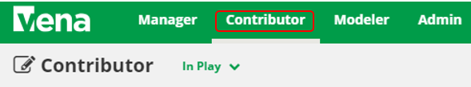

1. On the left side, click **Reports** (the centre section will reload to only display Reports)

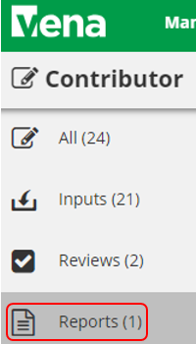

1. Click **Reports**

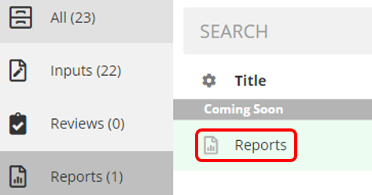

## CEAB Annual Attribute Report

This multi-page report provides a detailed snapshot of how the program is progressing for the current year. It includes an overall program summary and a separate report for each Graduate Attribute at the course level.

The report is built off a calculated average with a set order of operations, rather than directly based on the average of total students per outcome. At each level, the total is aggregated. For example, at the Section level, all sections are aggregated together, and from there, all terms are aggregated together to get a Yearly Average for all Sections per Course.

The order of operations for the calculation is:

1. LID’s (Learning Outcome)
2. Indicator
3. Attribute
4. Section
5. Year
6. Program

### Viewing the Annual Attribute Report

1. Select **View** next to **CEAB Annual Attribute Report.xlsm**
2. **Save** and **open** the Excel file
   1. If prompted, **Enable Content** and **Enable Macros**
3. Select the **Program** and press **OK**

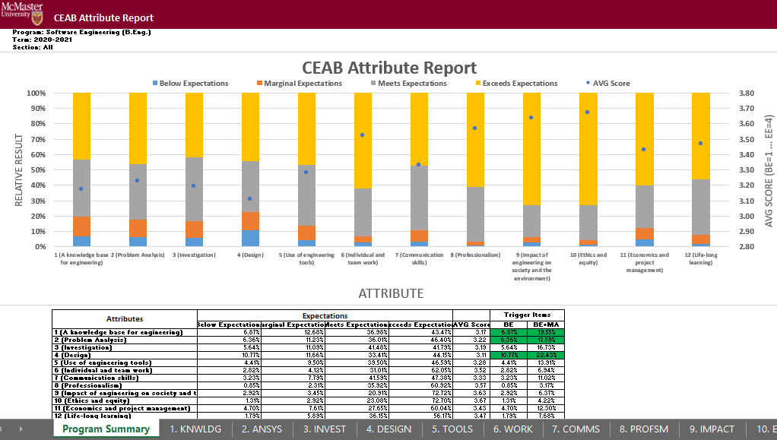

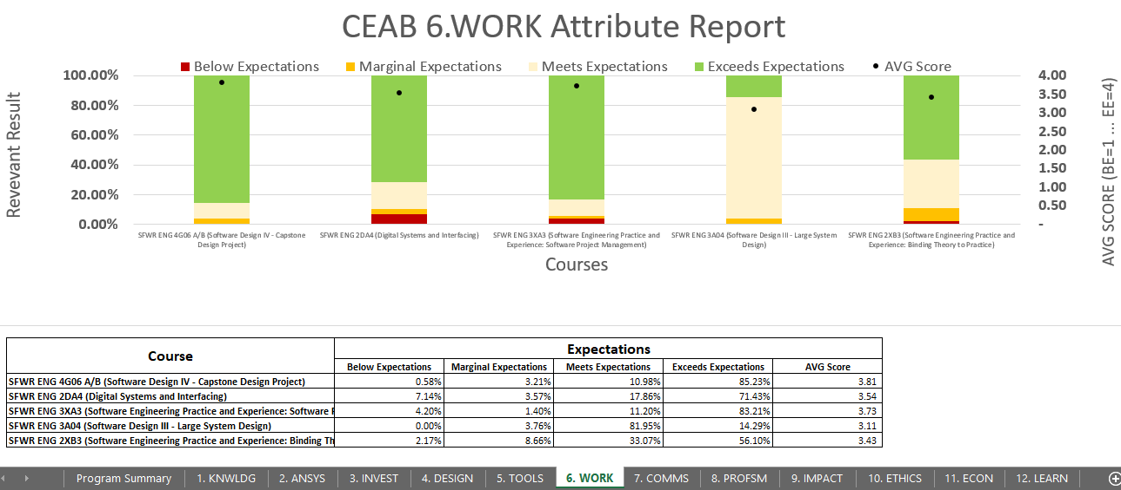

## CEAB YoY (Year over Year) Attribute Report

This report provides a look into the Average Score per Attribute, at a Program level, comparing it year over year. The Choose option that pops up allows you to choose the ending year that you’d like to view.

Prior to 2020-2021, the previous average scores were calculated based on the archived data of the # of students in each attribute/outcome. Starting in 2020-2021, the calculation is calculated on the new average process, as detailed in the CEAB Attribute Report section above.

The data for the current year, or most recent year is not automatically calculated. This YoY report uses archived data as it’s source. As a result, the archiving process must be executed to see the current year data. Note that this means the entire process must be completed, and the data from step 7a of the Vena Template Automation Average ETL must be executed. This is imperative to the process.

Please refer to the One Time Fix – ETL section of the CEAB Attribute Report.

### Viewing the YoY Attribute Report

1. Select **View** next to **CEAB YoY Attribute Report.xlsm**
2. **Save** and **open** the Excel file
   1. If prompted, **Enable Content** and **Enable Macros**
3. Select the **Program**, latest **Year**, and press **OK**

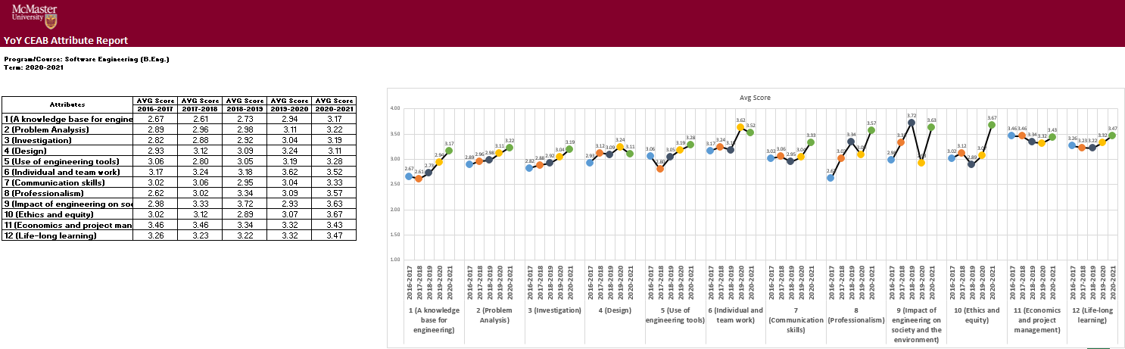

## Faculty and Curriculum Committee Recommendation Report

Displays the recommendations from the curriculum committee at both course and program level. This report can be viewed for any year where data is available. The data comes from the feedback provided in the Curriculum Committee Recommendations Input Template and as described in the Departmental Guide.

1. Press **View** next to Faculty and Curriculum Committee Recommendations Report
2. Select a Course/Program and Year
3. **Download** and remember the saved location of the report

To view an attached file:

* 1. Select a cell containing an attachment

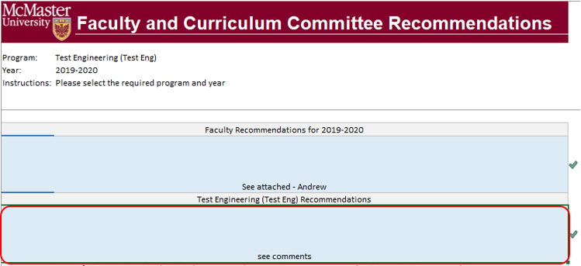

* 1. Click on **Comments** under **Vena** Tab
  2. On the right-hand side, select the attached file

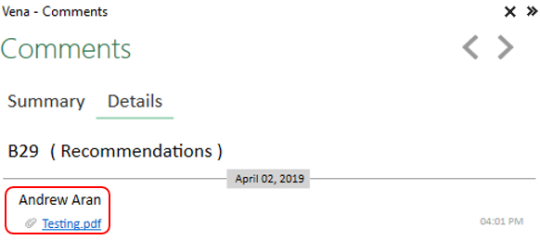

1. For macOS users, click  under Vena Comments
2. On the right-hand side, select the attached file

## Historical Course Measurement Report

Shows the historical trend for each course at different levels (indicator, attribute and all).

1. Press **View** next to Historical Course Measurement Report
2. **Download** and remember the saved location of the report
3. Select a Course (and Graduate Attribute if necessary)
4. If prompted, **Enable Content** and **Enable Macros**

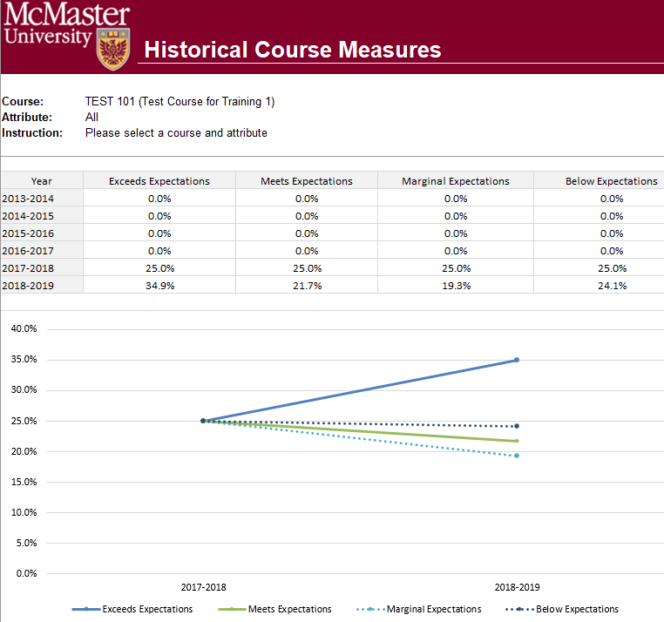

## Historical Program Measurement Report

Shows the historical trend for each program at different levels (indicator, attribute and all).

1. Press **View** next to Historical Program Measurement Report
2. **Download** and remember the saved location of the report
3. Select a Program (and Graduate Attribute if necessary)
4. If prompted, **Enable Content** and **Enable Macros**

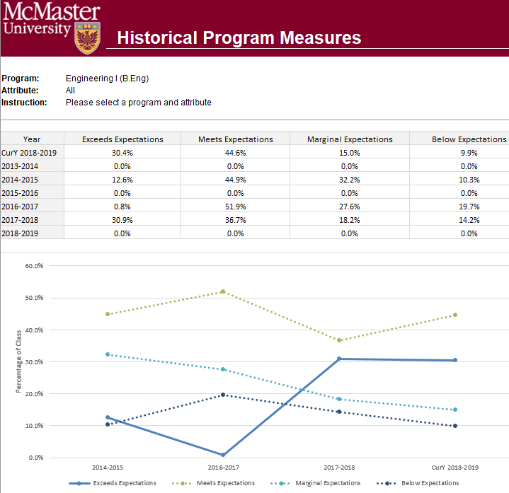

## Measurement Map Report

Indicates attributes the instructors will need to measure for a given year.

1. Press **View** next to Measurement Map Report
2. **Download** and remember the saved location of the report
3. Select a Program and Year
4. If prompted, **Enable Content** and **Enable Macros**

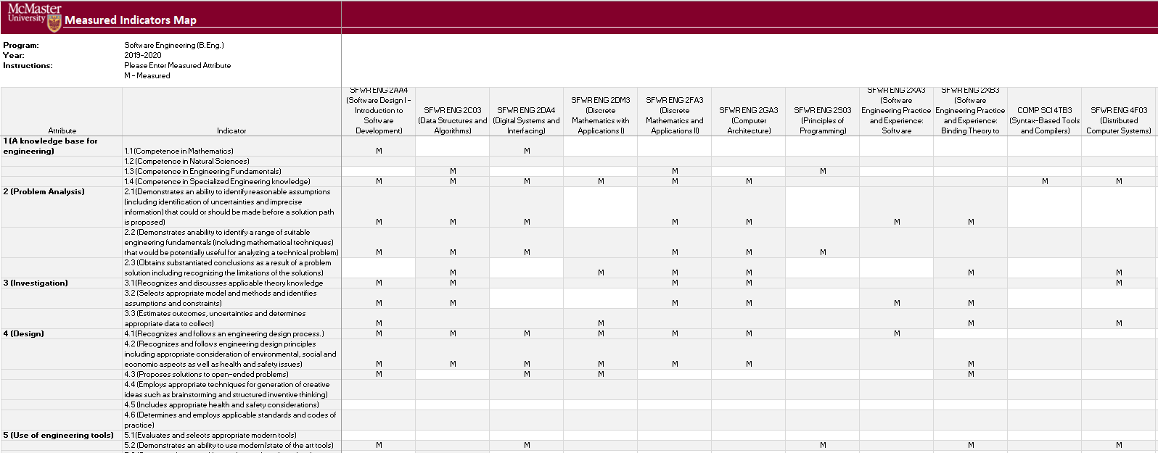

## Cascade

**\*\*\* Vena Feature currently available to Windows Users only \*\*\***

The cascade feature enables users to generate the same Vena report for multiple courses or programs. This feature eliminates the need to manually generate the same report for multiple courses.

### Generating a Mass Course Report

The steps below will show how to create

1. Select Contributor → Reports → Course Reports → **View**
2. Download and open the Course Report
   1. Click **Enable Editing** and **Edit Content** if the pop-up appears
3. Select a Course (belonging to the program), Year, Term, Section
4. Select the Vena Tab then click **Cascade**



1. For dimension, select **Program**

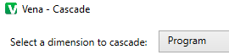

1. Select the courses belonging to the program (hold shift + click)

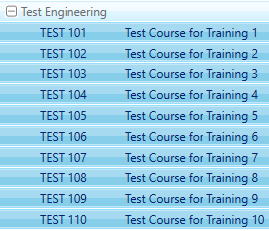

1. Change option from Cascade to Sheet to **Cascade to File**



1. Choose a location to save the files
2. Click **OK**
3. The Cascade feature will take approximately 5-10 minutes to complete

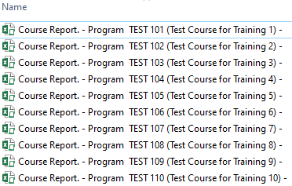

# Appendix I: Report Overview

|  |  |
| --- | --- |
| **Report Overview** | |
| **Report** | **Description** |
| Attribute Map Report | Displays all the courses for a program and the highest measure level for each Graduate Attribute |
| Attribute Map Summary Report | Similar to the Attribute Map Report, instead of displaying the level (A, D, I), the summary report displays an “X” to indicate that the course is measured for a specific attribute |
| CEAB Annual Attribute Report | This report includes an overall program summary and a separate report for each Graduate Attribute at the course level |
| CEAB YoY (Year over Year) Attribute Report | This report provides a look into the Average Score per Attribute, at a Program level, comparing it year over year |
| Course Report | Displays the rubric data entered from the Rubric Input Template in a bar chart. Also contains (if any) continuous improvement plans |
| Curriculum Committee Recommendations Report | Displays the committee recommendations for the program and its courses |
| Historical Course Measurement Report | Displays the course's year to year trend of the measured expectations |
| Historical Program Measurement Report | Displays the program’s year to year trend of the measured expectations |
| Indicator Map Report | Displays all the Graduate Attribute Indicators and the lowest measure level for each course |
| Measurement Map Report | Assigns an “M” for each course measured for the year |
| Rubric Entry Report | Displays the rubric entry status, indicates if a course is measured, the instructor's name, the last user to save rubric data, and when it was last saved |

# Appendix II: Previous Modification Log

|  |  |  |  |
| --- | --- | --- | --- |
| **Version** | **Modification date** | **Author** | **Comments** |
| 1.0 | July 5, 2016 | Evan Situ |  |
| 1.1 | August 28, 2016 | Evan Situ | Split the instructor document added section 3.1 and 1.4 |
| 1.2 | November 21, 2016 | Evan Situ | Removed Other Resource |
| 1.3 | December 20, 2016 | Michelle Zheng | Updated sections 2-6 |
| 1.4 | January 2, 2017 | Spencer Smith | Updated timeline, instructor input, reports, submit button |
| 1.5 | January 9, 2017 | Spencer Smith | Addition of password change instructions |
| 1.6 | January 19, 2017 | Spencer Smith | Removal of request to use the Submit button |
| 1.7 | January 31, 2017 | Spencer Smith | Explicit statement that each indicator has to have at least one learning outcome |
| 1.8 | April 19, 2017 | Spencer Smith | Explanation of columns in the Rubric Input template |